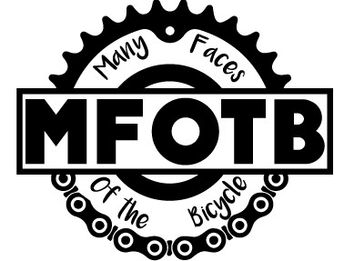

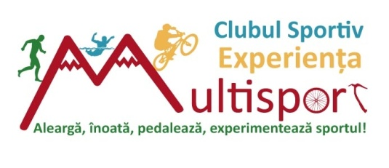

A GOOD PRACTICES E-BOOK

Biriș Alexandra
- Multisport Experience Club -

TABLE OF CONTENTS

Why an E-Book? pg. 3

- ONLINE DISSEMINATION & STRATEGIES pg. 4
- Facebook + FB Posts
- Publication

- PROMO MATERIALS pg. 7
- Posters & Flyers
- Logo

- EVENTS pg. 9
- Contest - Endomondo Cycling Challenge
- Facebook Contest
- Bike Event
- Spinning Event
- Volunteers Recruitment

- WORKSHOPS pg. 14
- School Presentation
- Games

Annexes pg. 17
Credentials pg. 26

Why an E-Book?

An E-Book is a very useful method for sharing information and ideas worth spreading. It is a way to leave a legacy behind every project or activity and teach other people about your practices, and most important, help them develop their work-flow, efficiency and well being at the work place.

MOFTB has brought many initiatives during the implementation of the project. Working with EVS volunteers helped creating a useful E-Book, containing good practices methods.

In this particular E-Book, you will find a top 11 list of useful practices that helped the MFOTB volunteers to have a successful project and activities with great impact on the community.
To make this E-book as accessible as possible, we divided the methods in the following categories:
- Dissemination
- Promo Materials
- Events
- Workshops
At the end of this E-Book, you will find practical examples of each method presented; that we hope will make an important tool for you and your activities in the future.

We are aware that every activity and every method presented has positive aspects and aspects that need to be improved. Of course, everything could have been done even better; there is always room for improvement. However, now that we look back, we want to share the aspects that we liked and considered efficient and most important those ones we can repeat and build activities starting from these initiatives.

Many Faces of The Bicycle was a great project that helped volunteers develop new abilities and competences, to learn about Romanian culture and the European Values.

LET’S BEGIN!
MOFTB was a great opportunity, for both parties, to learn and to create, and this E-Book is all about this great opportunity we all benefited from.

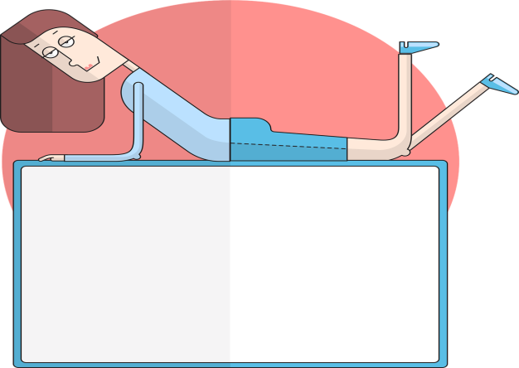

GOOD PRACTICE METHODS

- ONLINE DISSEMINATION STRATEGIES

- Facebook+ FB posts

The dissemination process proved itself to be of very high importance. Imagine if you were to set up a concert in the park – you can have the bands, the area, even some money, but you forgot to advertise your event and your organization. Nobody will come because they don’t know about it.

This specifically was the problem of the EVS Volunteers that were involved in MOFTB project. Who are we? What are we doing? What is the purpose of this project? What does MOFTB mean? There are the questions they had to answer, so the community can meet them, talk to them and trust them.

Create the Strategy! This is the first step in any activity you can think of. The planning stage can and will determine how successful your project/activity will be. When you start thinking about this, you should take into consideration every aspect of the project. We suggest you gather your team, create a brainstorming session, make decisions, start writing down ideas and finally write the strategy.

Keep in touch with the followers! It is of most importance to create a public page for your project. This can be a great opportunity for you to stay connected with the community you want to organize the project in. However, this is not enough. You need to take care of that page and post regularly. If not, people may forget or they may unfollow and you will prove a lack of professionalism. Try to include in your strategy an hour per week to post on the Facebook page. That will bring you visibility and will make your chances of having a successful higher.

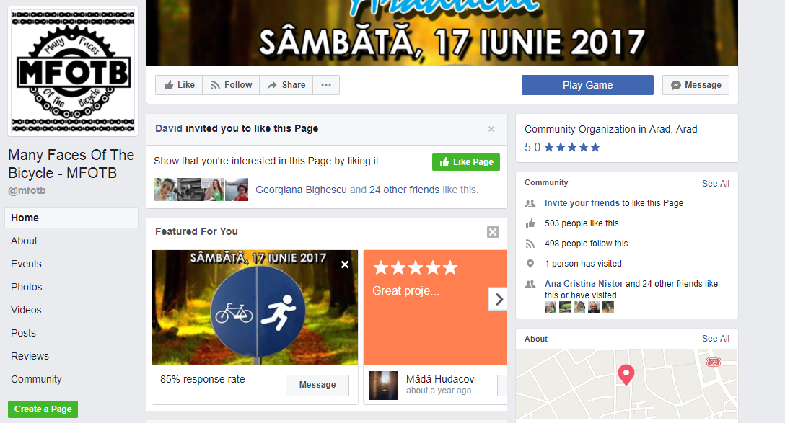
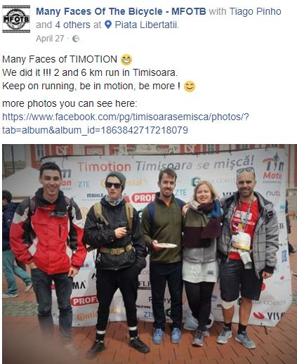
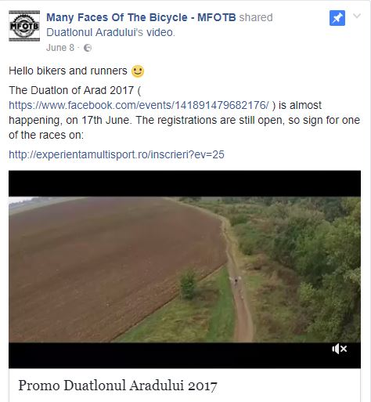

- Publication

The Publication is another great method of keeping in touch with the community. Some people do not have a Facebook Account but they are used to reading online newspapers. It is important for your activity to advertise it in order to have an impact and why not expanding the target group. Make sure you cover every way of communication according to the target group so you make sure the information is delivered.

The EVS volunteers involved in MFOTB chose to implement this method to promote the bike community and to promote the connection between the bike community in Arad and European network of bike routes Eurovelo, in Szeged.
They suggested creating a bike route from Arad to Szeged having the aim of promoting the cyclotourism in the region.

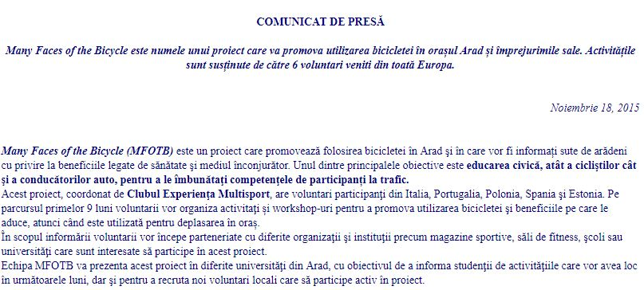

- PROMO MATERIALS

- Posters & Flyers

When you advertise an event or an activity, meeting the people you want to invite or creating a more personal bond with them is necessary. We suggest using the best friends of any marketing expert – The Poster and The Flyer
When using these two great tools, you may never forget to include:
- The name of the event
- The place where the event will be
- The date and the hour
- An attractive photo and a light design
- The Sponsors and Partners
- Do not create a crowded design , make it easy and simple so everybody can get the information as quickly as possible
- Logo
The logo of the project is very important. It is something that people should always remember and it helps you promote the project better. Start creating one! The logo is the project signature. Make sure you make it clear, simple and particular; connect it with the main purpose of the project.
After you create the design, make sure you choose the most circulated area in town to post the Poster and the most crowded places to share the Flyers – and always keep in mind – There is never too much marketing!

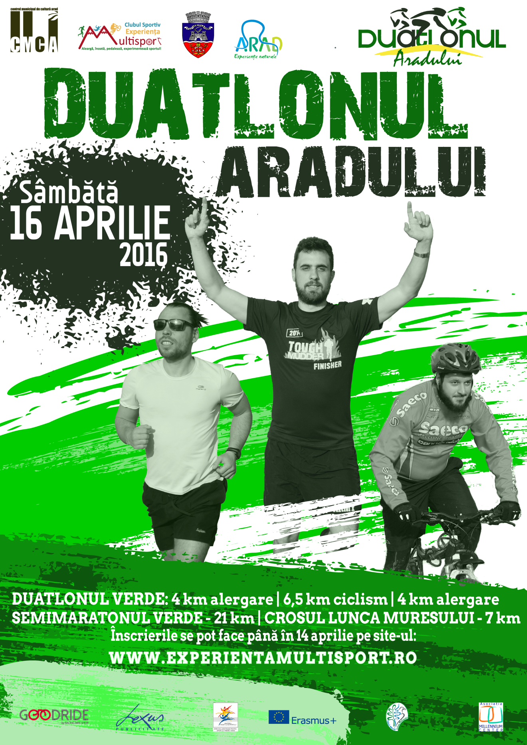

- EVENTS

- Contest - Endomondo Cycling Challenge

If you are going to create and implement an activity which is related to sports and cycling, then Endomondo Method can be a great idea. The MFOTB volunteers created a cycling event based on this free application that tracks the kilometres when you ride your bike.

To involve as many people as possible and create an attractive event for every group age, you can also give incentives, such as gifts, participation diplomas and prizes for the winners.
This can be a great idea to gather the locals into a competitive event that has its final aim to motivate and to promote a healthy lifestyle.

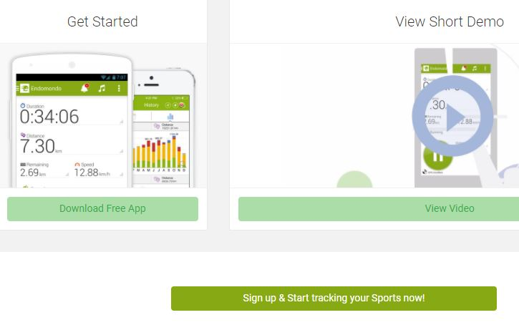

- Facebook Contest

Another great and useful idea is to create contests. Online area is very populated so why not take advantage of Facebook again? The MFOTB volunteers organized a photo contest on facebook, and they rewarded the winner with a prize. The aim of this idea is to involve as many people as possible in your activities and make yourself known in the community. Remember? You need to create a strong bond with the people and gain their trust. The volunteers did a great job! Why not try it yourself?

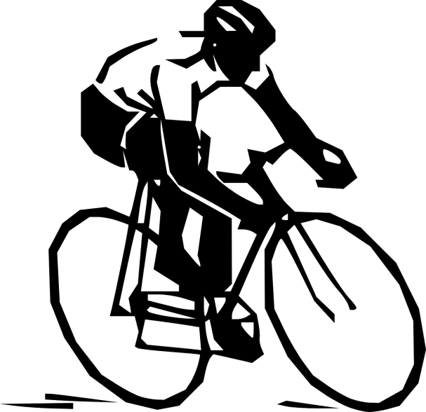

- Bike Event

Although every event you organized turned out to be successful, there is never too much information to know. Learn from others and don’t be stubborn. There are numerous events that are taking place, events that are similar to yours and if you want to be the best, you need to go, participate or be involved in any way into those events. You might find a great idea that you can implement in your city, you can make friends in other cities, and how knows, maybe one day you will collaborate with them.

There are a lot of advantages to this and literally no disadvantage. Gaining knowledge should be a priority for you for your personal and professional development!

MFOTB volunteers from the first stage participated in the Road Grand Tour in Râmnicu Vâlcea on 2016. They also created an E-Book containing photos from their experiences. The Volunteers from the second stage took part in the Arad- Bekescsaba Ultra marathon proving that they can also compete, not only organize.

You always need to find new methods to involve people, to attract them towards your objectives and to make an eligible example for them to follow you. There is never too much know-how and you can discover great ideas that you could have never thought of.

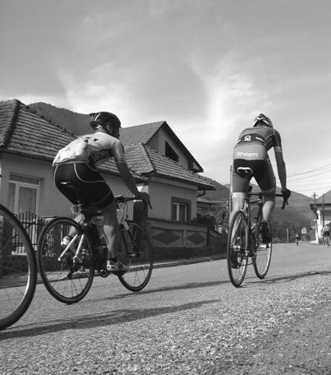

- Spinning Events

Spinning events were a trademark of MFOTB. The volunteers from both stages organized spinning classes for the locals or for other EVS volunteers. They managed to create a strong community that had fun by being healthier. It was not easy to facilitate such events but they managed to create a partnership with a local gym and once a week, they had the spinning class.

The spinning events were a great way for the volunteers to get to know the locals and for the locals to meet the EVS Volunteers and exchange good practices, experiences and cultures. As a consequence, they gained the confidence and the trust of the locals, having more and more participants for other events.

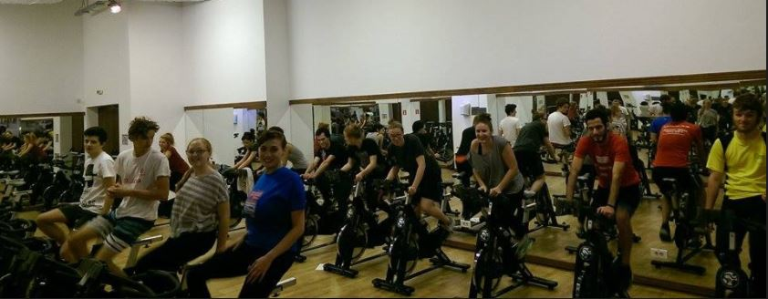

- Volunteers Recruitment

The recruitment of local volunteers is a very important aspect in the life of any event. MFOTB volunteers have found a way to involve the locals and to attract them into participating into the events they organized.

The EVS Volunteers organized a small event, an intercultural evening where they gathered local volunteers; presented them the MFOTB project and the project they want to organize. They invited the locals to be volunteers and created an opportunity for them to know each other better in order to collaborate efficiently in the following events.

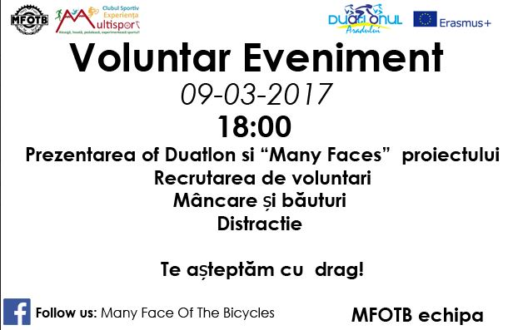

- WORKSHOPS

- School presentation

The Students can make a great target group. They are young, passionate and capable of making a change in the community. If you have great idea, why not share it with them. Many people are afraid of holding presentations in front of the students, but it is not that difficult and the reason is simple: They are closer to your age than the teacher’s. You can relate to them easily and make them be interested into your cause.

Create your presentation using a lot of pictures, graphics and simple designs. Tell them only what is important for them to make them curious. If the presentation is good, they will want to find out more. If they ask a question, that does not mean you were not good, but that they are interested to find out more, hence you’ve achieved your goal!

Take the MFOTB volunteers as an example. One of the main objectives of the project was to inform people about the advantages of riding a bike and about the legislation and traffic signs. By using non-formal methods, they manage to raise awareness in the young community of Arad about the dangers and problems that may appear if one does not pay attention.
School presentations and workshops can be your best friends if you know how to use them. Make sure you create a presentation that you would want to attend!
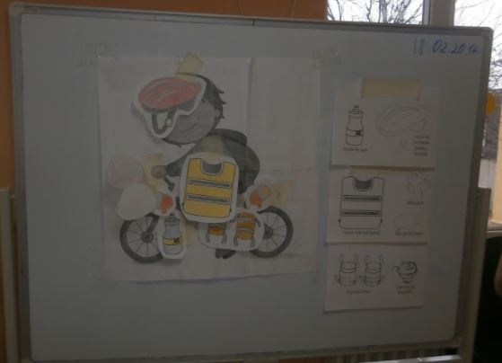

- Games

For creating a non-formal environment for learning, the EVS volunteers of MFOTB implemented during their activities games and energizers. It can get a little bit difficult to work with the target group so any method that help you create a bond with them is needed. Games and energizers can help you create a nice atmosphere and make people let their hair down and collaborate with each other.

You can always suggest a team-game so they can learn the basic principle of team-work. As an example, The EVS volunteers set up a basketball competition for youth, followed by an open session about the traffic legislation and signs
.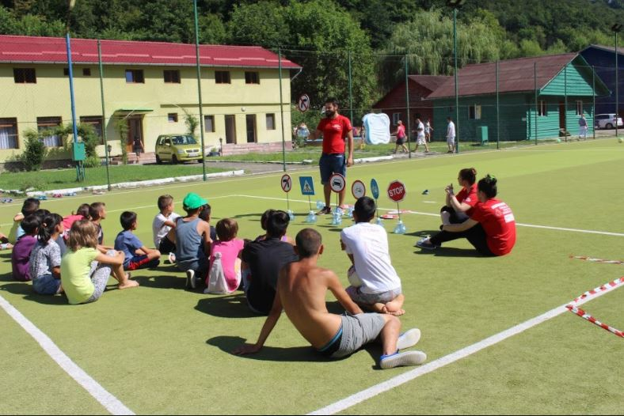

ANNEXES

Annex 1 - Strategies

S T R A T E G I E S F A C E B O O K

1. CREATE CONTENT OF VALUE TO INVITE PARTICIPANTS AND HAVE AN OPINION OF THE FOLLOWERS:
· Photos.
· Videos.
· Project information and news.
· Share interesting news, and associated news blog or website to redirect traffic.
· Create weekly and monthly events.
· Create quizzes and surveys, to generate interaction with followers.

2. PARTICIPATE IN OTHER FAN PAGES AND GROUPS.
The interaction between Fan Pages is very interesting from a strategic point of view. Participate in other similar pages and interact with them and their followers say and add value. Participating in other Fan Pages will be achieved, capture the attention of new users, made public.

3. SEGMENTATION
Implement segmentation, we can increase efficiency in content. Facebook offers several targeting criteria for choosing between age, relationship status, language, interests, training type and geographic location.

4. SCHEDULE PUBLICATIONS.
Arrange in advance and distribute the contents in the time of day that suits us. Please note the time difference between countries or continents; you will get to see the content in the most appropriate time for our community.

5. ADS TO PROMOTE FACEBOOK PAGE
Facebook is a very complete data base, due to the amount of accurate data that users provide in terms of origin, age, tastes, interests, studies, visited places, residence, etc. These data are well used an incredible search engine specific target audience and on this basis, we develop advertising campaigns aimed at a very specific audience.

6. ENTER #hashtag FOR EVENT MFOTB
We can see all the people involved in the event and link it to our social networks.

Annex 2 - Publication

CONNECTING ARAD WITH THE EUROVELO ROUTES IN SZEGED

Adrià TALLADA, Anton LINHOLM, Antonio BILOTTA
Clubul Sportiv Experienta Multisport

MFOTB (Many faces of the bicycle) is a project held by CSEM through the program Erasmus+, with volunteers from Italy, Estonia and Spain.
We are promoting the benefits of using the bike in the city of Arad from all his faces, the ecologic benefits, the social benefits and the health benefits. Until now we presented the benefits of the bicycle in different schools and universities and we started a line of workshops about road safety with children.
With this article we want to start raising awareness about the possibility of connect Arad with the already created network of European bike routes, Eurovelo, this can be the first step to a major change in one of the bike routes to cross Romania going through Arad and Timisoara.
Eurovelo It's a European cycle route network, currently it have more than 45.000 kms and its planned to have more than 70.000 kms when finished. Currently in Romania there are two routes planted the number 13 that goes north to south following the old trace of the iron curtain and the number 6 that follows the Danube river.
Our proposal is to create a bike route that joins Arad with Szeged, in this city there are two eurovelo routes planned, the number 13 and number 11; this connection will allow cyclo tourists that arrive to Szeged from one of this two routes to continue biking through Arad, visiting some important attractions in her way.
This will activate the cyclotourism in the area with all the benefits it have for the region¹ , there are different studies made in different countries that show the positive impact that the cyclotourism have in the region.
Also the infrastructure behind the cycloroute can be used for local citizens in their daily commuting, workers to their jobs and students to their schools, with the benefits it have for the employers³ and the health of the community⁴. There is a lot of research available about the benefits of the cycling in general.

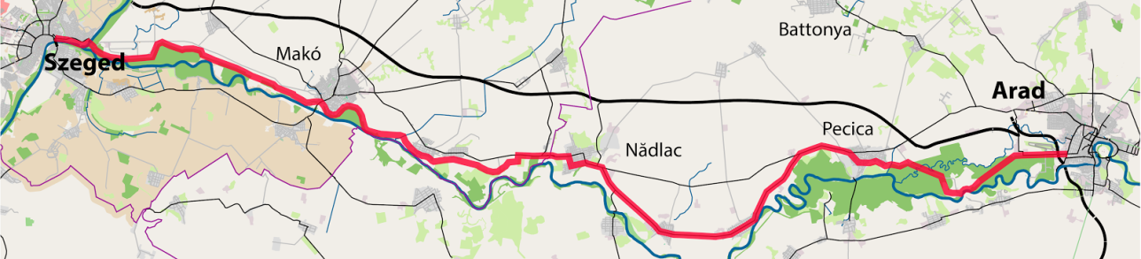
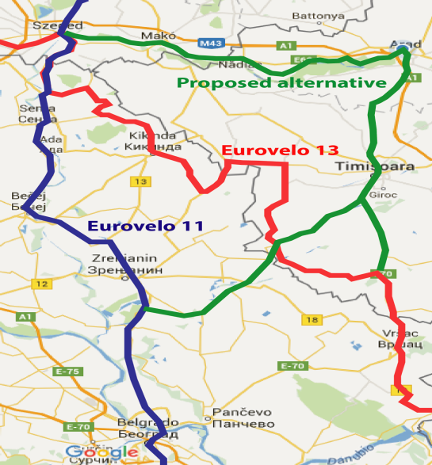
Proposed route:
The route we propose joins Szeged with Arad flowing parallel to the Mures River crossing the cities and villages, Makó, Nadlac and Pecica. Some of the important points that can't be missed are the Natural Park of Lunca Muresului and the Ortodox Hodos Bodrog Monastery.
From Arad there is the possibility of continuing the route down to Timisoara and then joining again the official routes of eurovelo 13 or eurovelo 11. It can be proposed as an official change of one of the routes.
Steps to be followed:
Identify attractive points of the route, and the touristic potential of them.
Identify possible partners among NGOs, federations, groups, companies, and institutions.
Identify the needs demands and concerns of the local community about the project.
Identify the services existing along the route, water sources, bike shops, tourist information centres, accommodations and if there is any need to improve or add some of them.
Check the quality of the surface of the route, the necessary changes and adaptations that should to be done and the signposting need.
Once all the stakeholders are involved and the needs identified a plan should be projected according to them.
- http://transformscotland.org.uk/wp/wp-content/uploads/2014/12/The-Value-of-Cycle-Tourism-full-report.pdf
- http://www.sustrans.org.uk/change-your-travel/make-change-your-workplace/selling-benefits-active-travel-employers
- http://www.sustrans.org.uk/change-your-travel/reducing-your-car-use/health-benefits-changing-your-travel

Annex 3 - Flyer

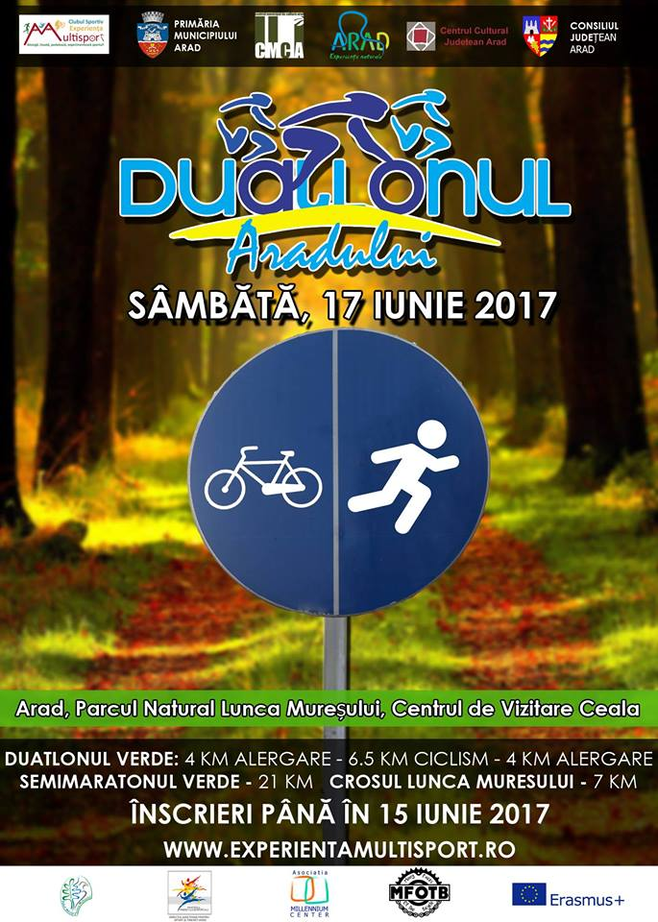

Annex 4 – Endomondo

The “Many Faces of the Bicycle” team encourages the cyclists of different level and experience from Municipality of Arad to join monthly Endomondo Cycling Challenge! Our mission is to motivate people to get and stay active. We do this by making it more engaging, more social and more fun to exercise!
THE MFOTB CHALLENGE
The Many Faces of The Bicycle (MFOTB) Challenge is an initiative by the Erasmus+ international volunteers of Clubul Sportiv Experienta Multisport to inspire residents of Arad to become active users of bike as healthy and efficient mean of transportation on a daily basis!
The first round of MFOTB Challenge will start on 01.01.2016 and will be held every month for duration of whole month. The new counting of kilometres will start at the first date of each month. The aim is to collect the kilometres by cycling and tracking the kilometres with the Endomondo mobile app. The three participants with the most kilometres in a month will be awarded with the prize from Clubul Sportiv Experienta Multisport and *ITS PARTNERS*!

WHAT IS ENDOMONDO?  Endomondo is a mobile app which is designed to track your workouts through GPS, provide audio feedback along the way and offer guidance on how to reach your goal. It’s a free personal trainer in your pocket which syncs with Endomondo.com, where you can access a full training log and analyze your fitness activity on Your mobile device or computer. https://www.endomondo.com | HOW CAN I GET ENDOMONDO?  You can download Endomondo sports tracker on your phone phone via Blackberry,Windows Phone, Google Play Store (Android) or App Store (iOS) for free. You can sign in by creating an account on www.endomondo.com or log in with Your Facebook or gmail account and start tacking your phisical activity
CONDITIONS
- The MFOTB team asks participants of the challenge to collect the kilometres by using the bike only. Participants who will not respect the fair play terms will face elimination from the challenge!
- Everyone can join the MFOTB Challenge. There are no geographical nor any other restrictions. However, only the residents of Arad municipality are eligible for the prizes!
- The Many Faces of the Bicycle team has right to change the rules and conditions of the challenge.
- Every participant who bikes 10-100 km will get a turtle online diploma 100-250 km rabbit online diploma 250-500 km leopard online diploma and more than 1000 km falcon online diploma.

Everyone can join the MFOTB Challenge at https://www.endomondo.com/challenges/25672707 or get the invitation by sending a message to:

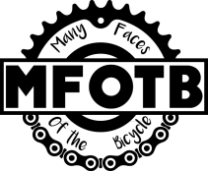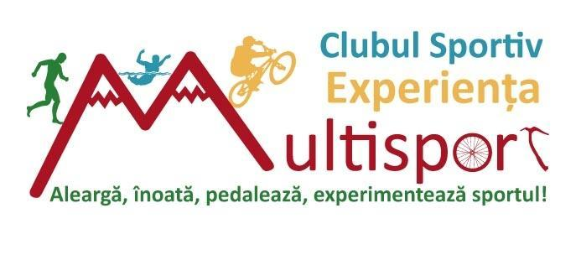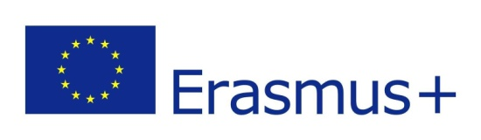
Dear Mrs/Mr
We are 6 volunteers from different parts of Europe (SPAIN, ESTONIA, PORTUGAL, ITALY, POLAND). We are running a project about sport called Many faces of the bicycle (MFOTB) and it’s coordinated by Clubul SportivE xperienta Multisport
Our goal is to promote the use of the bicycle by developing a cyclist community. Local people of Arad are having an important supportive role in this initiative.
From January 2016, we are starting a virtual cycling competition, using the Endomondo app.
This is an app for smart phone devices. It has been created for the people who are active in sports and want to measure the time, track the distances and compare their achievements with the other users. It`s a social network with the main emphasis on sport. It’s a free sports tracker which has over 20 million users worldwide.
What do we need from you?
We are looking for an award to the first three contestants with the most kilometres per month. The awards could be t-shirts, water bidons, small gadgets, small gift, discount, free bike check-up etc .
What we can offer you?
We will provide publicity for Your Company, sports club/shop. This contest will be presented in the different schools and universities of Arad and publicized in partnering sport clubs/bike related shops in Arad. The logos of the sponsors will be visible in all the presentations and signs, aswell noted on posters and social media channels.
You can see examples of contests here: https://www.endomondo.com/challenges

The target group of the contest is the local community of the city of Arad. The competition is also available for participants from outside of Arad and Romania. Only the participants from Arad are eligible for the prizes which will be granted for the first three most successful cyclists each month . This is a contest made in Arad and oriented to the bikers from community of Arad.

If you are interested in becoming our partner for this project ,please contact us here:
Contact:
1. e-mail: info.mfotb@gmail.com
2. Telephone: 0 754 446 924 – Roxana and 0 726 533 777 – Adria (only English)
3. Address: Eftimie Murgu 1 – 3 Arad
5. Facebook: https://www.facebook.com/mfotb

Annex 5 - Spinning

http://www.indoorcyclingmixes.com/5-indoor-cycling-class-games/

Tag! You’re it!

Playing "tag" on stationary bikes is a nice diversion for competitive bikers.
- Select two cyclists and designate one as the chaser and the other as the chased.
- The one being chased increases his speed. When the chaser reaches that speed, they have caught the person they are chasing.
- When the cyclist is caught, or tagged, she becomes the chaser, and begins to race against a new participant of her choosing.
- The chaser is then able to go into recovery mode until his name is called to be chased again

Circuits
- The instructor splits the class into three or more groups.
- Each group has a specific ride focus, which can include seated or standing climbs, flat sprints or intervals.
- After a set duration, the instructor calls out for the groups to rotate so they are performing a different drill.
- Each drill is the same length and can be repeated throughout the instructor's chosen length of time.

The Name Game
The name game is a great way for everyone to get to know each other and build a sense of belonging within an indoor cycling group.

Start by going around the group and have everyone say their name out loud. I always pick on someone and say if anyone forgets a name call on (insert name) and name someone in your group who likes a challenge.

How the game works:
- Everyone starts off in a standing position at a percentage between 40-60%.
- The instructor begins the name game by calling approximately one third of the names in the class.
- Everyone whose name is called must drop to their seat and sprint at 20-30%.
- The sprinters continue to sprint until they need a break (between 10-45 seconds).
- In order for them to come back up to the standing position at the original tension and have a break, they have to call someone's name and then that person drops and sprints.

Fun Additions:
- The Stalker: wait for someone who is just about to stand up and call their name right away
- Call more then one person's name
- Make it last for two to three songs
Variations:
- Start the group hovering, standing or sitting at any percent you choose, make sure that everyone is getting a workout, then add the name game sprints
- Turn the game into standing sprints. Have the group begin seated and when their name is called they stand up and sprint. *Best for an advanced group of participants

The Drafting Game
Games can make the time go by quickly, especially if you're leading a class or riding with a group. For example, spend a portion of your routine simulating a pace line.
- One rider -- or a group of riders -- rides hard for 30 to 90 seconds while another rider pedals more moderately -- to simulate drafting, which is something riders do out on the open road.
- Two or more riders pedal in a tight line and the first rider cuts the wind resistance for the other riders. In class, wind resistance isn't an issue, but you can have your riders pretend, taking turns upping their resistance to "fight the wind."
- Once the first rider's time is up, he signals the next "drafter" to take over.
- Repeat this drill several times to make a complete workout or include it along with hills and speed play.

Trick or Treat! Choose Your Fate
This is an easy way to incorporate “tricks” (i.e., challenging drills) and “treats” (i.e., easier drills). Simply have participants pick a card, either trick or treat, and the predetermined drill assigned to that card will dictate what drill is performed. I’ve decided to have six possible tricks and three possible treats.

Possible Tricks:
- Two minutes of jumps with 30 second break; repeat two to three times
- Two one minute standing hill climbs and a couple two minute standing hill climbs; 15 second recovery between each climb
- Five one minute sprints with 30 seconds recovery between each sprint
- 15 squats off the bike followed by one minute of seated hill climb; repeat two times (be watchful of participants’ footwear particularly if they are wearing cycling cleats)
- 10 sprints for 15 seconds. Recover for 45 seconds.
- Attack the pack power! Six intervals of seated power for 30 seconds, recover for 30 seconds

Possible Treats:

1. Standing jog/ride for two minutes

2. Meet your neighbour spin out. Participants discuss best and worst Halloween costume they ever wore for three minutes.

3. Steady time trial pace for six minutes singing to the song everyone knows the words to, Thriller (the album version is 5:58)

http://healthyliving.azcentral.com/cycling-games-spin-class-1533.html

Annex 6 – Example of Workshop Material

MATERIALS WORKSHOP

- Cardboard / Cartons (Number of signals 16)
- Whistle (1)
- Scissors ( 3 - 4 Minimum)
- Glue (1 - 2)
- Tape (Colour Black): For the way (photo)
- Large Colours papers (6 places in the street, cinema, school, 2
house, hospital, mall): Draw the places.
- 2 people are bicycle (we need papers, colours pens for draw and
rope)
- 2 people are cars (we need papers, colours pens for draw and rope)
- Large White papers (For the second and third game)
- Normal Papers
- Rulers (2)
- Pencils
- Print
- Prepare Stars for each places (Is the goals for each children)
- Prepare one board for to choose the mission. (We need colours
pens for draw the places, scissors and tape).

CREDENTIALS

This E-Book has been created with the information and materials provided by the following volunteers in the Many Faces of the Bicycle project:

Stage I
Adria Tallada Cebrian
Anton Linholm
Antonio Billota
Dora Sofia Henriques Matos
Patrycja Bernatek
Rebeca Navarro Moralles

Stage II
António Rafael de Sousa Tavares
Beata Zaborowska
Daniel Martí Romero
Silja Saar
Tiago Luis Abreu Pinho
Tomasz Szwichtenberg

Partners:

CESIE (Giuseppe)
Continuous Action (Annli)
JOINT (second stage) - Federico
Mundus (Alberto)
ProAtlantico (Sofia)
Semper Avanti (Hanna)

EMS Team:

Andreea Vesa
Cristina Nistor
Delia Roman
Georgiana Bighescu
Michal Piatek
Mina Cristina
Narcis Vlasin
Noemi Zombori
Ramona Babos
Roxana Tomos
Sorin Victor Roman

